**Flight Controllers**

<https://fpvfrenzy.com/quadcopter-flight-controller-shootout/?fbclid=IwAR1ySMdf-HCW0dT2YXuFcyY4r1LEtAXZoOtmm3i7D5rrtO38oS15z4CI07A>

**Components**

|  |  |  |  |
| --- | --- | --- | --- |
| **COMPONENTS** | **NAME** | **SPECS** | **PRICE** |
| ***Motors*** | *EMAX MT1806 KV2280 Brushless Motor* | KV: 2280  No. of cell: 2 - 3S  Framework: 12N14P  Shaft: 2mm  Diameter: 26.7mm  Length: 23mm  Weight: 18G  Propeller: 13cm - 15.5 cm | **$12.55** |
| ***ESC*** | Emax Simonk Series | Current: 12A 20A 25A 30A 40A available  Input: 2-3S LiPo  Max speed: 210,000 rpm for 2-pole, 70,000 rpm for 6-pole, 35,000 rpm for 12-pole. | **$12.02** |
| ***ESC Connection Distribution Board For Multi-Axis Model*** | ESC Connection Distribution Board For Multi-Axis Model | Weight:15g  The pitch of the edge:45mm  Compatible with MK KK flight control installment pitch of holes  Compatible with MK KK flight control system  Can connect 1-8 ESC | **$2.28** |
| ***Frame*** | F450 Quad Frame | *Width :* 450mm  *Height:* 55mm  *Motor Mount Bolt Holes :* 16/19mm  *Frame* *Weight:* 282g (Without electronics)  *Diagonal* *Wheelbase:* 450mm  *Takeoff* *Weight:* 800g ~ 1600g | **$10** |

**EMAX MT1806 KV2280 Brushless Motor detailed specs**

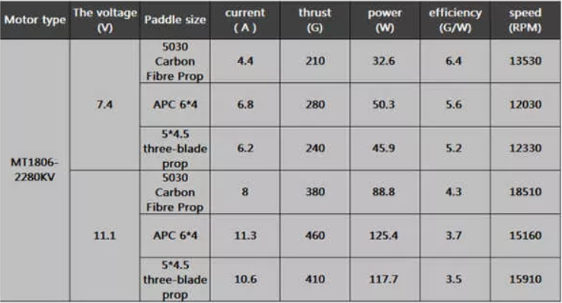

**Emax Simonk Series detailed specs**

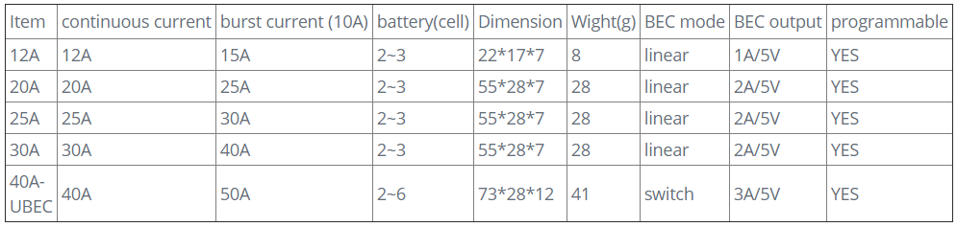

**F450 Quad Frame:**

